Youth in the Church
  - Growing in Faith & Service
Lent & Easter 2021

REadings and Prayers
It’s a new day in the neighborhood – let us rise up and meet it!
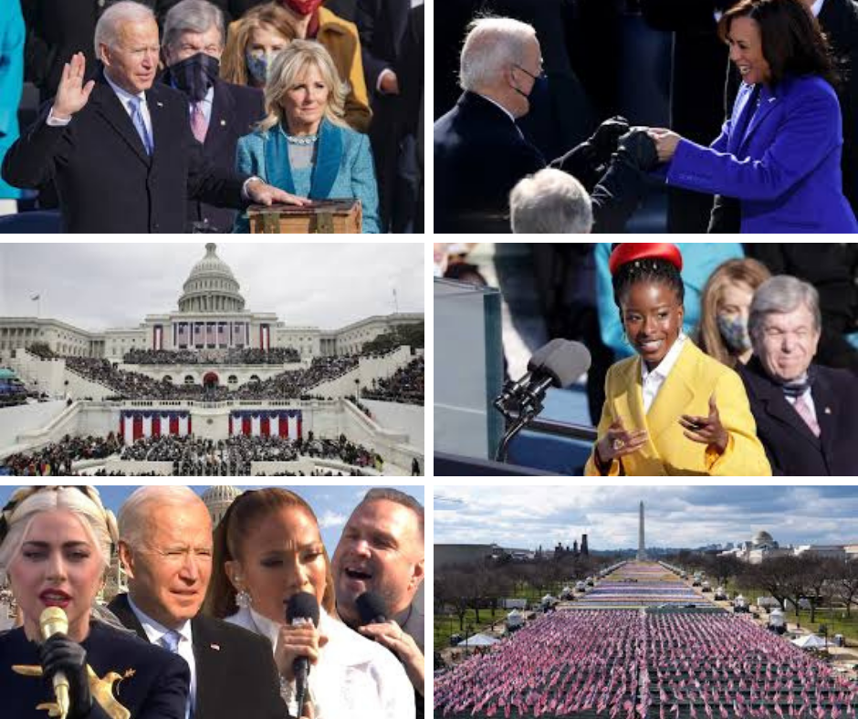

A New Day

It was I am glad to say, an inaugural like none in my memory. Sure, the location was the same and the oath of office was too. But watching it this year was a reminder that hope is alive, and love wins.

I wonder what you guys were thinking. I look forward to talking with you about what you saw and felt.

The nation will be yours soon – your job to vote and hold those elected accountable. I count on you to do a better job than some of our current population and leaders.

Lent is often understood as a time of sacrifice and giving up…REALLY? Like we haven’t given up enough this last year? Lent is more than this. Lent is more than foregoing chocolate or cheeseburgers. Lent at its best is a time to take time. And take the measure of our lives, our choices and our dreams.

I’ll repeat this paragraph form the last booklet:
Be kind to yourself – this has been a long difficult year of missing what we would normally be doing. Be patient with yourself and with those around you. The virus has in many ways shut down our lives, keeping us from fun with friends and families, sports, vacations, and probably our holiday gatherings and traditions, and now likely another spring with no prom, no graduation ceremony. I do not want to add to your work or your stress. I want to give you my support and love even though we cannot be together. Maybe this Lent and Easter just say a few simple prayers over the days – use them to calm you and remind you of the love that surrounds you. Use them to look forward to a day when we can be back together.

God our Father, you see us growing up in an unsteady and confusing world: Show us that your ways give more life that the ways of the world, and that following you is better than chasing after selfish goals. Help me to take failure, not a s a measure of my worth, but as a chance for a new start. Give me strength to hold my faith in you and to keep alive my joy in your creation; through Jesus Christ our loved. Amen.
Adapted from the BCP, page 829

That amazing poem – Amanda Gorman, twenty-something genius
The Hill We Climb
When day comes we ask ourselves,
where can we find light in this never-ending shade?
The loss we carry,
a sea we must wade.
We've braved the belly of the beast,
We've learned that quiet isn't always peace,
and the norms and notions
of what just is
isn't always just-ice.
And yet the dawn is ours
before we knew it.
Somehow we do it.
Somehow we've weathered and witnessed
a nation that isn't broken,
but simply unfinished.
We the successors of a country and a time
where a skinny Black girl
descended from slaves and raised by a single mother
can dream of becoming president
only to find herself reciting for one.
And yes we are far from polished.
Far from pristine.
But that doesn't mean we are
striving to form a union that is perfect.
We are striving to forge a union with purpose,
to compose a country committed to all cultures, colors, characters and
conditions of man.
And so we lift our gazes not to what stands between us,
but what stands before us.
We close the divide because we know, to put our future first,
we must first put our differences aside.
We lay down our arms
so we can reach out our arms
to one another.
We seek harm to none and harmony for all.
Let the globe, if nothing else, say this is true,
that even as we grieved, we grew,
that even as we hurt, we hoped,
that even as we tired, we tried,
that we'll forever be tied together, victorious.
Not because we will never again know defeat,
but because we will never again sow division.
Scripture tells us to envision
that everyone shall sit under their own vine and fig tree
and no one shall make them afraid.
If we're to live up to our own time,
then victory won't lie in the blade.
But in all the bridges we've made,
that is the promise to glade,
the hill we climb.
If only we dare.
It's because being American is more than a pride we inherit,
it's the past we step into
and how we repair it.
We've seen a force that would shatter our nation
rather than share it.
Would destroy our country if it meant delaying democracy.
And this effort very nearly succeeded.
But while democracy can be periodically delayed,
it can never be permanently defeated.
In this truth,
in this faith we trust.
For while we have our eyes on the future,
history has its eyes on us.
This is the era of just redemption
we feared at its inception.
We did not feel prepared to be the heirs
of such a terrifying hour
but within it we found the power
to author a new chapter.
To offer hope and laughter to ourselves.
So while once we asked,
how could we possibly prevail over catastrophe?
Now we assert,
How could catastrophe possibly prevail over us?
We will not march back to what was,
but move to what shall be.
A country that is bruised but whole,
benevolent but bold,
fierce and free.
We will not be turned around
or interrupted by intimidation,
because we know our inaction and inertia
will be the inheritance of the next generation.
Our blunders become their burdens.
But one thing is certain,
If we merge mercy with might,
and might with right,
then love becomes our legacy,
and change our children's birthright.
So let us leave behind a country
better than the one we were left with.
Every breath from my bronze-pounded chest,
we will raise this wounded world into a wondrous one.
We will rise from the gold-limbed hills of the west.
We will rise from the windswept northeast,
where our forefathers first realized revolution.
We will rise from the lake-rimmed cities of the midwestern states.
We will rise from the sunbaked south.
We will rebuild, reconcile and recover.
And every known nook of our nation and
every corner called our country,
our people diverse and beautiful will emerge,
battered and beautiful.
When day comes we step out of the shade,
aflame and unafraid,
the new dawn blooms as we free it.
For there is always light,
if only we're brave enough to see it.
If only we're brave enough to be it.

Let’s be it! Take time to look for light and to be light. Step out of the shade “aflame and unafraid.” Together, we will “raise this wounded world into a wondrous one.”

Write down something positive about yourself every day

God our light,
make your Church like a rainbow
shining and proclaiming to all the world
that the storm is at an end,
there is peace for those who seek it
and love for the forgiving. NZ BCP, page, 573

A LENTEN IDEA - IDENTITY
Scripture tells us that after his baptism, Jesus was “led by the Spirit” into the wilderness where he fasted for forty days and forty nights (Matthew 4:1-2, NRSV). When we teach about Jesus’s time in the wilderness, we often focus on temptation, sin, and resistance. Jesus is an example for us—he was tempted but did not sin. However, in Henri Nouwen offers a different lens for this story, one that draws on the connection between Jesus’s baptism, the voice from heaven that said, “This is my Son, the Beloved, with whom I am well pleased,” and his time in the wilderness. Nouwen writes,

“Jesus’s temptations in the desert, described in the Gospel of Luke, are temptations to move him away from [his] core identity. He was tempted to believe he was someone else: You are the one who can turn stone into bread. You are the one who can jump from the temple. You are the one who can make others bow to your power. Jesus said, ‘No, no, no. I am the Beloved of God.’ I think his whole life is a continual claiming of that identity in the midst of everything.”

What if we view Jesus’s time in the wilderness as a time when he was tempted to stray from his identity as the Beloved Son of God? What would this mean for our observance of Lent? Could we see the difficult wilderness times of our lives as times that holding onto our identity as Beloved of God is most challenging? Could we take on a practice during Lent that reminds us of our Belovedness? Could we see Lent as an opportunity to remove the distractions and obstacles in our lives that prevent us from living into our core identity as Beloved of God?
Building Faith

What’s getting in your way? What distraction or obstacle will you put aside?
See your beautiful self as beloved of God. Then act out of that gift. Beolved.

Happy Easter Everyone!
Hoping for good weather, low virus percentages, and time to gather behind the VMFA for some SNACKCHATS!
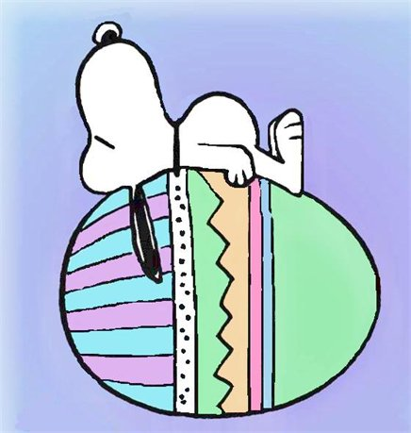
You bring your beverage – I’ll bring the snacks.

Love and prayers always! Malinda, Bill, Ryn, and Kent

